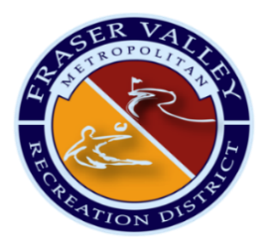

Fraser Valley Metropolitan Recreation District
Board and Staff Retreat
Balcony House Board Room, Winter Park Resort
Thursday, October 15, 2026

Agenda

8:00am Board of Directors Focus Group: BerryDunn

9:15am Staff Arrival/Continental Breakfast

9:30am Financial Forecast & Strategy

11:10am 2027 Draft Compensation Plan

12:15pm Lunch

12:45pm 2027 Draft Budget

2:00pm Asset Management

2:30pm Community Needs Assessment Update

3:30pm Teambuilding @ The Foundry

